Child and Family Services of Western Manitoba
‘Because You Matter’ Youth in Care Conference 2017
For Youth in Care Ages 13-20

Saturday May 27, 2017
9:00 am registration
9:30 am to 3:00 pm Conference
*Snacks and a Pizza Lunch are included (Gluten free and Vegetarian options will be available)

Registration is FREE
Everyone must register as space is limited. Please attempt to register 5 youth and 1 worker for your Agency as we want to ensure that the majority of the spots are filled with youth
Youth must register through their social worker/Agency

Agency _____________________________________________________________
Agency Contact Person ________________________________________________
Agency Mailing Address ________________________________________________
Agency Phone Number _________________________________________________
Email _______________________________________________________________
 | First and Last Name (please print) | Age
Youth 1
Youth 2
Youth 3
Youth 4
Youth 5
Adult/Support Person |  | (phone number)

Registration deadline:
Final Registration DEADLINE (first come, first served registration) April 21, 2017
Please send completed registration form and consent forms to Breanna Dick:
Must submit a consent form for each youth under 18 years of age
Unit 4 - 613 10th Street, Brandon MB R7A 4G6
Fax : 204-726-7030
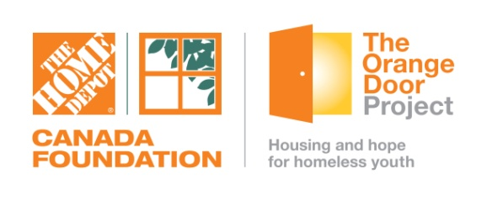
Email : breanna.dick@gov.mb.ca Supported by :

Registration confirmation will be through email only

